Course: High Performance Computing Lab

Practical No 1

PRN: 22510050

Name: Prathmesh M. Sarwade

Batch: B6

Title: Introduction to OpenMP

Problem Statement 1 – Demonstrate Installation and Running of OpenMP code in C

Installed MinGW and installed the necesarry packages.

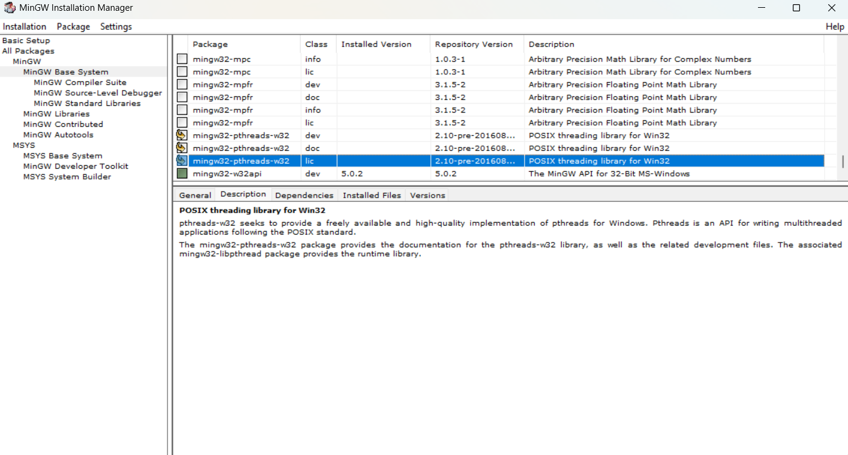

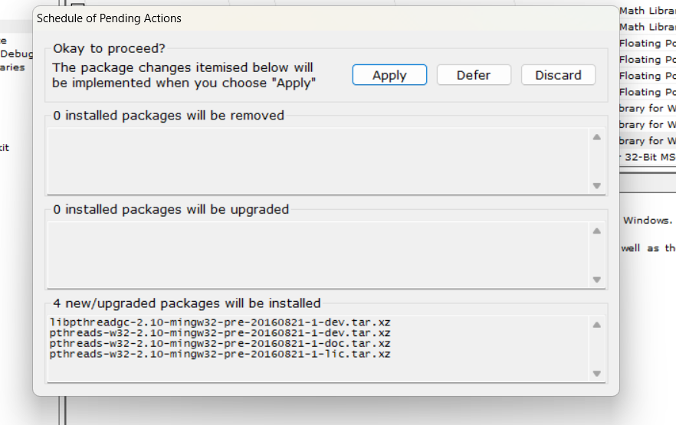

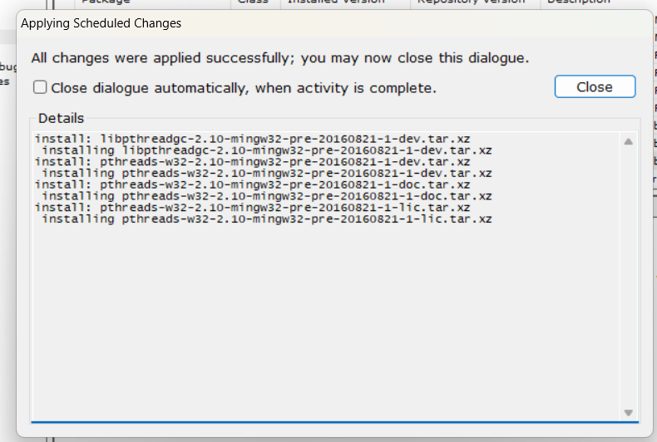

Then, to run a program in OpenMP, we have to pass a flag `-fopenmp`.

To run a basic Hello World :

Code and output snapshot :

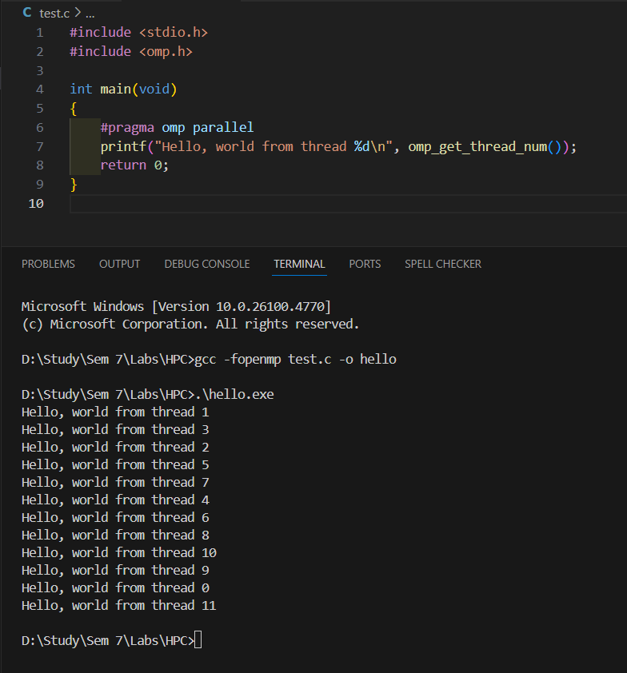

Problem Statement 2 – Print ‘Hello, World’ in Sequential and Parallel in OpenMP

Code snapshot:

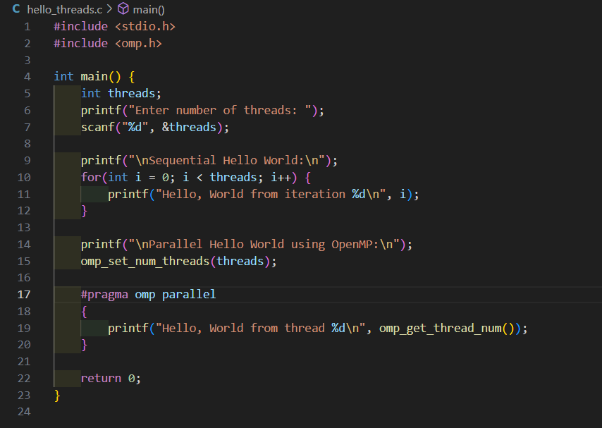

Output snapshot:

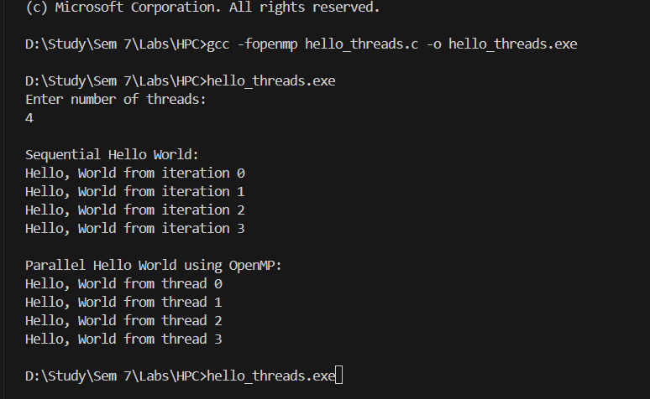

Analysis:

In the sequential part, the program prints “Hello, World” one after another in proper order because only the main thread is working.  
In the parallel part, multiple threads run at the same time, so each thread prints its own message. The order can change because all threads are running together. This shows how OpenMP allows the program to use multiple threads to execute faster.

GitHub Link: make a public repository upload code of an assignment and paste its link here.

https://github.com/prathmesh967/HPC-Assignment

Problem statement 3: Calculate theoretical FLOPS of your system on which you are running the above codes.

FLOPS=Cores×Clock Speed (Hz)×FLOPs per Cycle per Core

Cores: 6

Processors: 12

Clock speed: 3030 GHz = 3.30 x 10^9 cycles/sec

FLOPS = 6 x 3.30 x 10^9 x 16 => 316.8